## Practical 4: CSS

## Preparation:

1. You should have gone through Syntax and Selectors section under Learn CSS module at [codecademy](https://www.codecademy.com/learn/learn-css).
2. Your checklist: 

☐ CSS selectors are used to Select elements on an HTML page so that

they can be styled.

☐ relationship between elements (parent/child/sibling)

☐ type/tag selector

☐ nested/descendant selector

☐ id selector

☐ class selector

☐ attribute selector

☐ attribute selector

☐ pseudo selector such as :hover

Download the **practical4(StudentFile).zip** file from Blackboard.

## Part A: Try it out! (40mins)

1. Add the required CSS to style the SimpleMe.html

## 

Font family used of the whole document is Verdana, if not found use sans serif.

All text in the document by default is centralized.

Height of hr is 20px and width is 70% of that of the document; its background colour is green.

Image size is 400x300; with border of 1px in green.

1. Add the required CSS to style the myPlan.html

## 

Font family used of the whole document is Verdana, if not found use sans serif.

All text in the document by default is centralized.

Height of hr is 20px and width is 70% of that of the document; its background colour is green.

Image size is 400x300; with border of 1px in green.

The paragraph indicating the source of image should be in italic and 60% of the default font size only.

The span of class funny: font colour is #00FF00, with text shadow of colour ;rgba(0,255,0,0.6); font family is Brush Script MT, if not found cursive; font size is 2 times the default size.

Style the table based on the output. Width of table is 70% of the document width.

## Part B: Challenge I: Putting it together (30mins)

1. Add the following to the top (beginning of body) of SimpleMe.html.

<header>

<h1>Noo Wo Ri</h1>

<nav>

<ul>

<li><a href="#" class="current">Personality</a></li>

<li><a href="myPlan.html" >Plan</a></li>

<li><a href="#">Family</a></li>

</ul>

</nav>

</header>

1. Add the following to the top (beginning of body) of myPlan.htm.

<header>

<h1>Noo Wo Ri</h1>

<nav>

<ul>

<li><a href="SimpleMe.html" >Personality</a></li>

<li><a href="#" class="current">Plan</a></li>

<li><a href="#">Family</a></li>

</ul>

</nav>

</header>

1. Create an external CSS to style the header; such that the 2 web pages are linked as below:

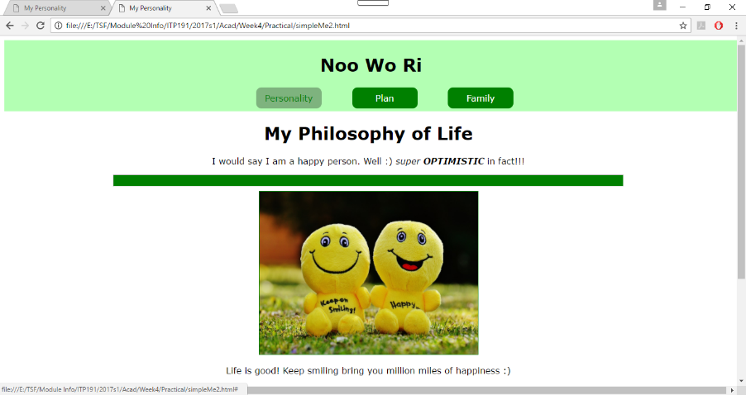

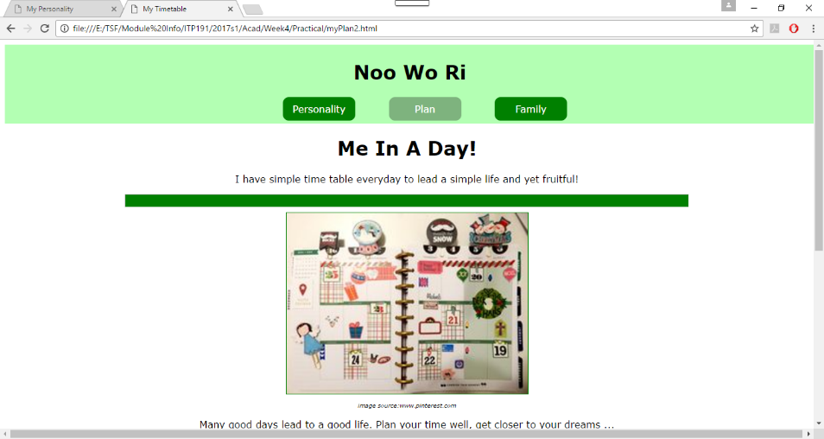

Background colour of header is rgba(0,255,0,0.3).

When the link is mouse over, background color change to white and color of font to green.

The link of current page is of background color rgba(0,0,0,0.3).

## Hint: Styling List to for hyperlinks

## By default, every list item i.e. li start from a new line. To change the behaviour, we will have to use the CSS display property to style it with the value of inline or inline-block. This is very often used when styling the list of hyperlinks.

## Difference between inline and inline-block:

## 

## Part C: Challenge II (20 mins)

1. Create another the web page (e.g. family.html). Create your own content and style them with some consistency with the previous 2 pages.
2. Link the page to your work in Part B.
3. Do you find that there are some common styling in the 3 pages you may group them in one common external CSS?

What is the advantage of doing that?

*In fact, certain level of consistency in styling across web pages within the same website will help to create “the branding” of your site. It eliminates confusion. Your users will get a hang of your website in a much shorter time.*

1. Zip all your work and submit to Blackboard.

***External CSS is preferred***